3/24/2026
CREATED BY:
Hiran patel
Email: HIRAN.PATEL1005@GMAIL.COM
CONTACT nO: 7575894647
India Sales Performance Analysis Dashboard
Multi-Regional Sales Performance and Trend Monitoring

Contents
Project Objective 2
Data Governance and Architecture 2
Date Preparation Standards 2
Data Modeling and Its Design: 2
Key Performing Indicators (KPIs) 2
Visual Analysis Framework and Visuals 2
Visual Representations 4
Region and Category Wise Bar Chart 4
4
Sales Trend 4
4
Regional Hierarchy 5
5
Category Analysis 5
5
Top Performers 6
6
Advanced Analytics 7
Intelligence Measure 7
Segmentation 7
UX and Performance Analysis and Optimization 7
Deliverables 7

Figure 1: Sales, Profit, and Quantities by City and Category 4
Figure 2: Current Month and Previous Month Sales Trends 4
Figure 3: Sate Wise Total Sales 5
Figure 4: City Wise Total Sales 5
Figure 5: Region Wise Total Sales 5
Figure 6: Total Sales and Total Profit Category Wise 5
Figure 7: Top Performers by Total Sales, Total Profit, and Margin% 6

Project Objective
The objective of this project to monitor the sales performance across various states of India and its market segments. The dashboard will highlight through KPIs to stakeholders in order to evaluate profitability, regional growth, total sales, and consumer trends.

Data Governance and Architecture

Date Preparation Standards
We have used an ETL tool for maintaining data integrity and consistency.
- Data Redundancy & Deduplication: Remove all duplicate values or records based on orderId.
- Normalization: Standardize text fields such as city, state, category for uniform filtering.
- Null Handling: Replace null values using power query tool.
- Data Modeling: Create a custom date hierarchy to compare the date wise and region wise sales.

Data Modeling and Its Design:
The modeling architecture follows a star schema for optimized query performance:
- Fact Table: Orders Data
- Dimensions Table: Custom date table

Key Performing Indicators (KPIs)
The dashboard will show the real-time card visuals for the following metrics
- Financials: Total Sales, Total Profit, and Profit Margin in (%).
- Operations: Total Orders and Average Order value (AOV).

Visual Analysis Framework and Visuals
The reporting layer is divided into five strategic modules
Module Visual Type Objective
Geographic Analysis Bar Visual sales, profit and quantities by cities and category
Sales Trends Line Chart Analyze the sales month and previous month wise
Regional Hierarchy Bar Chart Analyze the region, state and city wise sales using drill-down
Category Analysis Donut Analyze total sales and total profit by category wise
Top Performers Ranking Table Identify the top five cities by top revenue, profit and profit margin

Visual Representations

Region and Category Wise Bar Chart
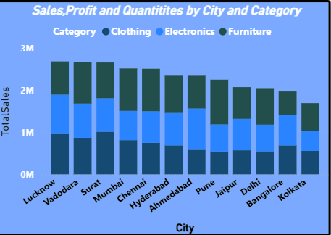
Figure 1: Sales, Profit, and Quantities by City and Category

Sales Trend
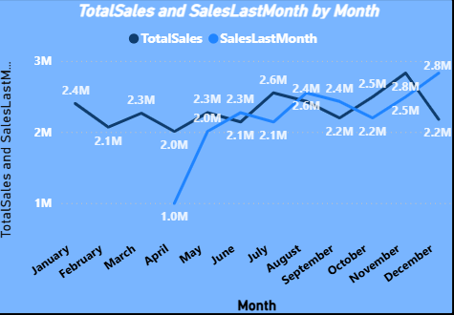
Figure 2: Current Month and Previous Month Sales Trends

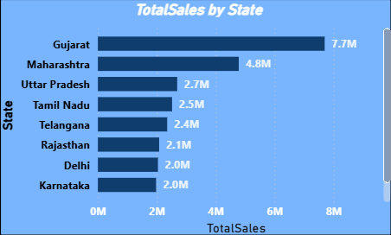
Regional Hierarchy
Figure 3: Sate Wise Total Sales
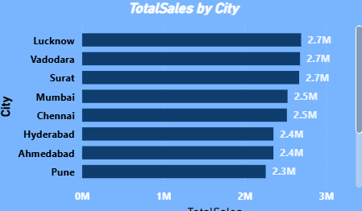
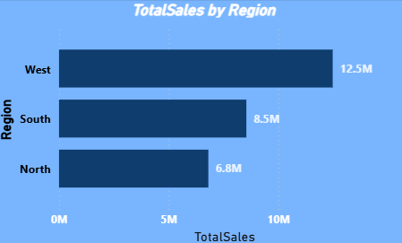
Figure 4: City Wise Total Sales
Figure 5: Region Wise Total Sales

Category Analysis
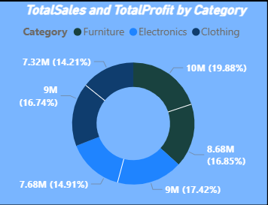
Figure 6: Total Sales and Total Profit Category Wise

Top Performers
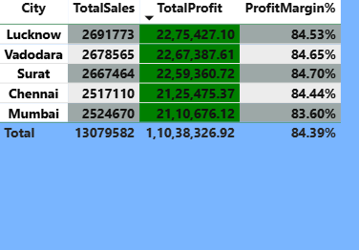
Figure 7: Top Performers by Total Sales, Total Profit, and Margin%

Advanced Analytics

Intelligence Measure
The solution will utilize complex DAX measures to identity critical metrics:
- Time Intelligence: year -over-Year and Month-over-Month growth percentages.
- Business Logic: Running totals ana contribution % by region or category.
- Discount Impact: Analyse the low profit transactions driven by high discount rates.

Segmentation
To simplify deeper segmentation, the following calculated columns will be utilized and added to identify categorical measures:
- Profitability Level: High/Low
- Discount Categorization: Low/Medium/High
- Order Segmentation: Small/Medium/Bulk

UX and Performance Analysis and Optimization
- Interactivity: Slicers for Category, Region, and Date will control all visuals
- Visual Cues: Conditional formatting will apply “Stoplight” logic like Green for positive profit and Red for negative profit.
- Optimization: High- cardinality fields will be lowered or limited, and more and more measures will be used or prioritized over calculated columns to ensure dynamic and prompt report loading.

Deliverables
The final dashboard will be interactive and data driven suitable for presentations. It will especially empower the business in order to identify high revenue potential across different regions, most profitable categories as well as the direct correlation between discounts and bottom-level erosion.

